UNIVERSITI MALAYSIA SARAWAK
Faculty of Computer Science and Information Technology
TMA3084 Software Engineering Laboratory | Semester 1, 2026/2027
MEETING MINUTES

A. Meeting Details
Group No. / Name | Group 21 – ByteChew | Lab Group / Demonstrator | Group 2 – Mr Raynold anak Kabai
Project Title | Tracking App
Meeting No. | 03 | Project Week / Milestone | Week 3  ☑ M1 ☐ M2 ☐ M3 ☐ M4
Date | 23/10/2026 | Time (start – end) | 21:00 – 21:50
Meeting Type | ☐ Team meeting ☑ Client meeting ☐ Lecturer / demonstrator consultation
Mode / Location | ☐ Physical ☑ Online Google Meet: https://meet.google.com/ses-brgh-nce
Chairperson | Muhammad Afiq bin Sakub | Minute Taker | Ahmad Danish bin Alin
Meeting Objective | Present the low-fidelity wireframe draft to the client, collect feedback, and clarify required changes to the event information application.

B. Attendance
No. | Name | Matric No. / Organisation | TSPi Role / Position | Present / Absent | Signature
1 | Muhammad Afiq bin Sakub | 102719 | Team Leader, Planning Manager | ☑ P ☐ A | 
2 | Ahmad Danish bin Alin | 102384 | Quality/Process Manager | ☑ P ☐ A | 
3 | Adenillo Sheldy anak Stephen | 102372 | Support Manager | ☑ P ☐ A | 
4 | Shelsy anak Nicholas Felix | 102958 | Development Manager | ☑ P ☐ A | 
5 | Syafik bin Sali | 102978 | Client Liaison/ Developer | ☑ P ☐ A | 
6 | Lambert | Skybylamby | Client | ☑ P ☐ A | 
Absent with reason |  | None

C. Review of Previous Action Items First meeting: write “Not applicable”
No. | Action item from previous meeting | Owner | Status | Remarks
1 | Fix the requirement gaps found when checking the proposal against the PRD format and rubric | Adenillo | ☑️ Done  ☐ In progress  ☐ Not started
2 | Complete the references section in APA 7th edition | Shelsy | ☑️ Done  ☐ In progress  ☐ Not started
3 | Do the final consistency check of wording, table numbering and FR-ID alignment across all sections after everyone has proofread their own sections | Danish | ☑️ Done  ☐ In progress  ☐ Not started
4 | Draft low-fidelity wireframes of the app and include how screens differ for Student, Organiser, General Public and Admin | Shelsy and a  Adenillo | ☑️ Done  ☐ In progress  ☐ Not started
5 | Schedule the next client meeting | Syafik | ☑️ Done  ☐ In progress  ☐ Not started

D. Agenda and Discussion Copy an agenda block for each additional item
Agenda Item #1: Presentation of the Wireframe Draft
Discussion | The team presented the low-fidelity wireframe draft for the event information application. The proposed application is intended to help students and public users discover activities and events taking place. The wireframe was presented to gather client feedback on the interface, event information, attendance features, user roles, and campus map functionality.
Decision | The client’s feedback and requested changes were recorded for review and incorporation into the next wireframe version.
Reference

Agenda Item #2: Discussion of Client Feedback and Required Changes
Discussion | The team discussed how event attendance should be represented, what information should be available to event organizers, how event audience categories should affect visibility, and how venue markers should behave after an event ends.
Decision | The requirements listed are to be reviewed and incorporated into the application design, subject to confirmation of any outstanding details.
Reference

E. Client Feedback and Requirement Changes Client meetings only; otherwise “Not applicable”
No. | Feedback / change requested by client | Affected requirement (FR‑xx) | Agreed response
1 | Attendance should use an RSVP-style approach, allowing users to indicate that they intend to join an event. | FR-13, FR-14, FR-15 | Update the attendance design to support RSVP / join registration.
2 | The attendee count visible to students and public users should count only users who have joined / RSVP'd at the event. | FR-13, FR-14, FR-16 | Display the number of registered / RSVP'd users, not a live count of people physically present.
3 | Each event should be identified as either a public event or a student-only event. | FR-12, FR-09 | Add an audience/category field when an organiser creates or manages an event.
4 | The venue pin on the map should be removed once the event has ended. | FR-04, FR-05 | Update the map behaviour so an event’s venue marker is removed after the event ends; confirm the precise timing and handling of ended events

F. Action Items
No. | Action item | Owner | Due date | GitHub Issue # / TSPi task
1 | Update the wireframe to include RSVP registration, allowing users to indicate their intention to attend an event. | Shelsy | 30/10
2 | Revise the attendance display to show the total number of registered users instead of actual live attendance. | Adenillo | 30/10
3 | Update the event creation requirements to distinguish between public and student-only events, ensuring appropriate event visibility. | Syafik | 30/10
4 | Review and update the campus map requirements to remove event location markers after an event has ended. | Danish | 30/10
5 | Review and coordinate the implementation of client feedback, ensuring all requested changes are reflected in the updated wireframes and SRS document. | Afiq | 30/10

G. Adjournment and Next Meeting
Meeting adjourned at | 21:30 | Next meeting (date / time) | 23/10/2026, 22:00
Next mode / location | Google Meet | Proposed agenda | Identify outstanding issues and required changes.

H. Sign-off
Prepared by  Minute Taker  Signature: ______________________  Name: Ahmad Danish bin Alin  Date: 23/10/2026 | Verified by  Team Leader  Signature: ______________________  Name: Muhammad Afiq bin Sakub  Date: 23/10/2026 | Acknowledged by  Client  Signature: ______________________  Name: Lambert Gan anak Thomas  Date: 23/10/2026

Attachment

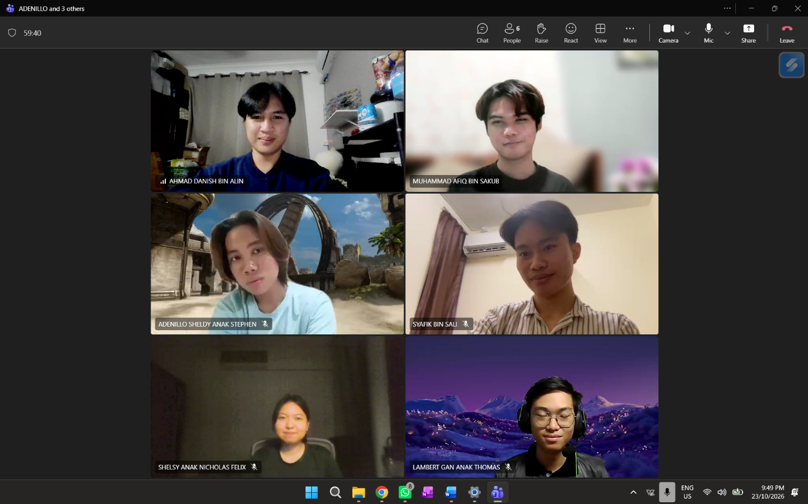

▸ Attach evidence for client meetings (attendance photo or online-meeting screenshot). If an AI tool was used to transcribe or summarise this meeting, record it in LOGAI and check the minutes for accuracy before signing.

